**Socket Programming**

Computer network programming involves writing computer programs that enable processes to communicate with each other across a computer network

Socket programming is a way of connecting two nodes on a network to communicate with each other. One socket (node) listens on a particular port at an IP, while other socket reaches out to the other to form a connection. Server forms the listener socket while client reaches out to the server

What is socket and how it works?

The server socket listens for incoming connections. A server creates a socket, binds the socket to an IP address and port number (for TCP and UDP), and then listens for incoming connections. When a client connects to the server, a new socket is created for communication with the client (TCP only).

Difference between Socket and Port

Socket and Port are two terms used in computer networks. The difference between socket and port is that the socket is the interface of sending and receiving data on a specific port while the port is a numerical value assigned to a specific process or an application in the device.

Is Socket A hardware or software?

Socket. When a computer program needs to connect to a local or wide area network such as the Internet, it uses a software component called a socket. ... It is important to note that these sockets are software

Why do we need socket programming?

Socket programs are used to communicate between various processes usually running on different systems. It is mostly used to create a client-server environment

**In the Word of Sockets**

Socket() – Endpoint for communication.

* **listen()**: is used to establish and start TCP listener.
* **bind()**: is used to bind-address (host-name, port number) to the socket.
* **accept()**: is used to TCP client connection until the connection arrives.
* **connect()**: is used to initiate TCP server connection.
* **send()**: is used to send TCP messages.
* **recv()**: is used to receive TCP messages.
* **sendto()**: is used to send UDP messages
* **close()**: is used to close a socket.

**Lab Task**

Task 01: How to get IP address and host name

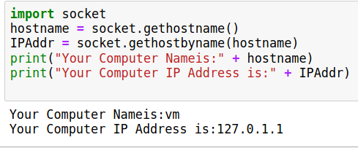

Task 02: How to get All Ip address

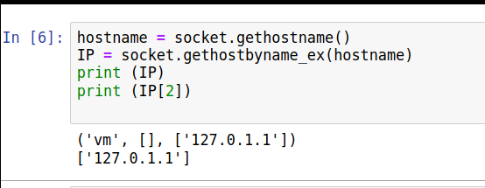

Task 03 Get Ip address from name

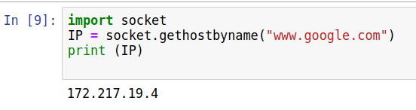

Task 04 Get application name from port number

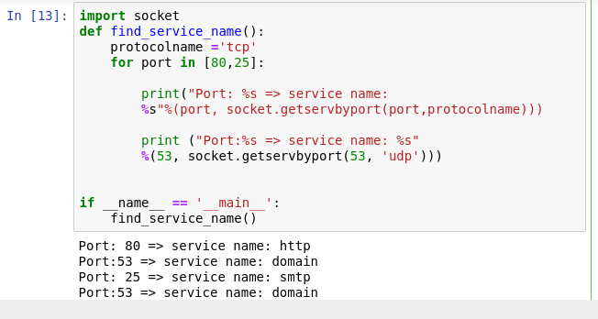

Task 05 Scan Ports

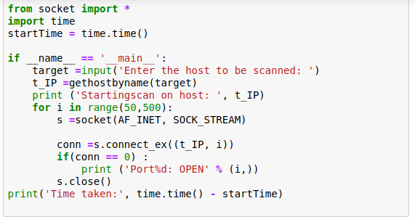

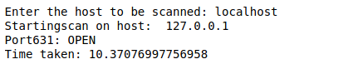

Task 06 Create a socket and connect it with Google

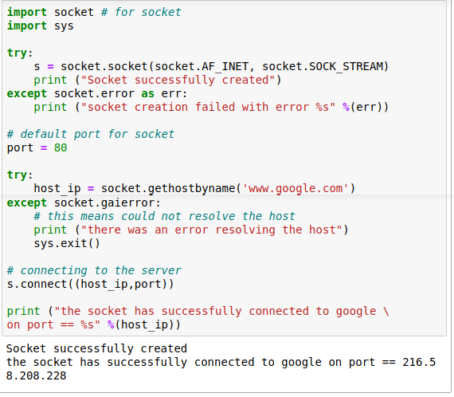

Exercise:

Get port number and protocol from application name.